V8T.V VMS Solution / MVP Solution Feedback / September 6, 2026 / R Duguay
GP Portal / GP Admin
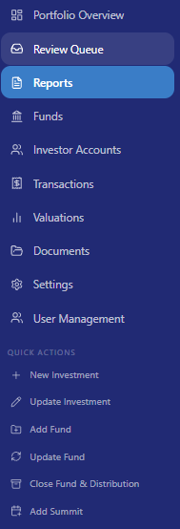 | Reports: We could change this Section name to ‘Company Reports’ as this is the area where we are doing requests, review, and approvals for posting to record.
As I was looking at the Menu, it struck me that we should probably also have a Menu Item: Companies

I do see a means to ‘Add Company’ on the Portfolio page, but it would be perhaps intuitively positive to also have an added Menu Item that is specific to companies only.

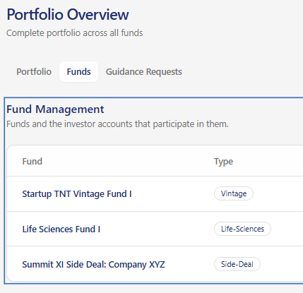 | On the Portfolio Overview page, regarding ‘Funds’ can you make the names of the funds something that includes a hover box, and could be clickable to go to the Funds screen for further review… like the ‘Company’ box we could have a ‘Fund View’ and ‘Edit’ buttons at the top as options.

Portfolio Overview
Portfolio Overview screen | There is a section (top button) regarding Founder requests, but another button (add-on) could be a Chat (or Messages) section where Founders, or LPs could interact privately with GPs, or similarly GP Admins.
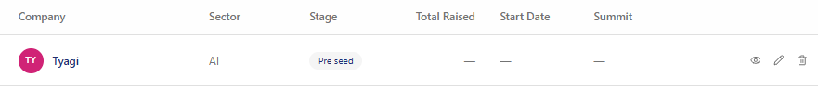
For this list screen. Good execution on list. | Feature add: Could we add in another column for ‘Last Valuation’ and ‘As of date’ reference.  For the Fields for Company, for each of the ‘Company’ names… could we indicate a hyperlink with underline so that there is an intuitive idea that companies can be found through the hover box (already indicated)… I like the hover box with ability to ‘View Full Profile’
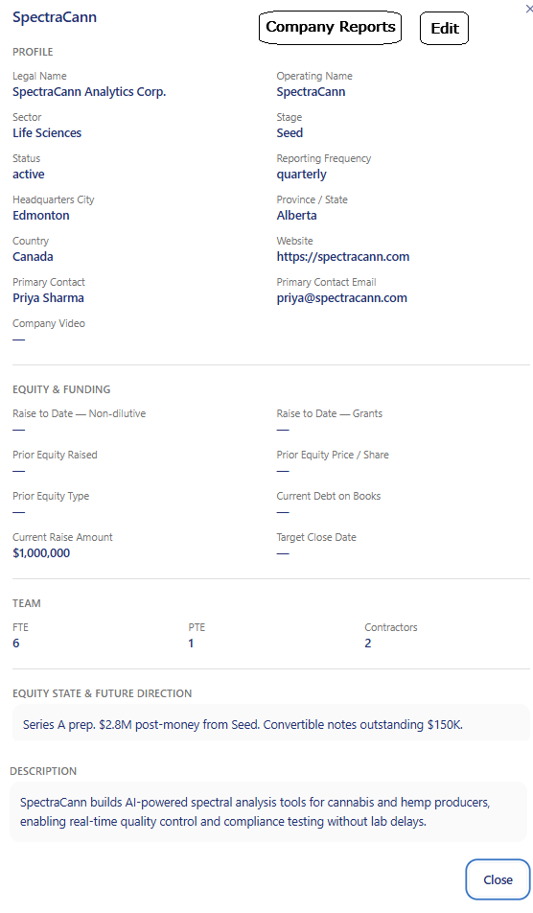 | On the Company box, following View Full Profile:  - Could you add a couple buttons per image, (1) Company Reports, that takes us to that Company Reports screen, and (2) Edit, which would provide a means of editing the Company; this being provided for GP Admins only… The Company Reports button could be provided to associated GP, LP and Admins.  - Under the PROFILE Section, I would like a field for ‘Simplified Data Room’ where we will make it possible to add a link to a Dropbox… which we will manage.  - I am thinking that we may want to add a unique Menu Item section in the VMS Application relating to Datarooms… but let’s discuss this idea before addressing.  - I would like a section following ‘EQUITY & FUNDING’ which would be titled ‘VALUATION’ with fields from latest Valuation (details)  - it makes this box a bit bigger, so maybe we need a scroll bar as well here.

Transaction / Transaction Type:
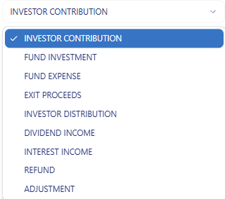 | Transactions: I like this section but I think it is a bit un-intuitive regarding the ‘Transaction Types’… which presents under the ‘Record Transaction’ dropdown…  What I am thinking could be easier for people (GP Admins, mostly)… is that for each ‘Transaction Type’ once it is selected (from the drop-down box), we provide an ‘Information box’ which provides a description of the Transaction, and how it should be applied…
Payment method: | I think we should add an ‘Other’ in the dropdown, and then present an open text field to fill in.

Documents Menu:
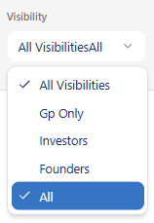 | There is a minor glitch here in this dropdown… there should just be one item… probably indicate ‘All Roles’ and delete ‘All’

General Items:
URL Add | I am thinking we would use the name of ‘Value Management System’… so would like to also have the URL: vms.vital8t.ventures  … in addition to the current valuehub.vital8t.ventures URL
Migration to Canada Servers | Per earlier notes, please migrate the hosting location to Canada (currently in US).
Terms of Service & Privacy Policy | Laura & I can collaborate on creating these content pieces which will be needed before we onboard anyone.
Process Workflows: User Guidelines | Laura & I will collaborate on creating some basic workflow guides and associated one-pager type files for each of the roles:  - GP Admin  - GP / Investor  - LP / Investor  - Founder

Feedback file drafted September 6, 2026 / Version 1.0 / Randy Duguay / V8T.V

